**Manufacturing**

**Forecasting**

Project Proposal

­­­

By

**Miss. Nontra Mahachanont 542115026**

**Mr. Parinya Panyanak 542115034**

Department of Software Engineering

College of Arts, Media and Technology

Chiang Mai University

Project Advisor

________________________

**Mr. Phudinan Singkhamfu**

|  |  |  |  |  |  |  |  |
| --- | --- | --- | --- | --- | --- | --- | --- |
| **Document Name** | **Version** | **Status** | | **Date** | **Viewable** | **Reviewer** | **Responsible** |
| **Documents** | | | | | | | |
| Manufacturing Forecasting- Project Proposal_V.0.1.docx | - Add Chapter 1  - Introduction & Background  - Adjust Project Name | Draft | 07-02-2014 | | NM, PP, PS | NM, PP | NM, PP |
| Manufacturing Forecasting- Project Proposal_V.0.2.docx | - Adjust Abstract  - Add Chapter3  - Quality Standards | Draft | 27-02-2014 | | NM, PP, PS | NM, PP | NM, PP |
| Manufacturing Forecasting- Project Proposal_V.0.5.docx | - Add Chapter2  - Business Review  - Business Tools  - Software review  - Technology Review  - Development Tool Review  - Add Chapter4  - Project Plan | Draft | 01-03-2014 | | NM, PP, PS | NM, PP | NM, PP |
| Manufacturing Forecasting- Project Proposal_V.0.7.docx | -Add Chapter5  - References  - Adjust Technology Review  - Adjust Schedule & Milestone | Draft | 03-03-2014 | | NM, PP, PS | NM, PP | NM, PP |
| Manufacturing Forecasting- Project Proposal_V.0.9.docx | - Fix inappropriate word | Draft | 04-03-2014 | | NM, PP, PS | NM, PP | NM, PP |
| Manufacturing Forecasting- Project Proposal_V.1.0.docx | - Project proposal | Released | 05-03-2014 | | NM, PP, PS | NM, PP | NM, PP |

**Document History**

**\*NM = Nontra Mahachanont**

**\*PP = Parinya Panyanak**

**\* PS = Phudinan Singkhamfu**

**Abstract**

As bakery manufacturer today, they contain large data and more complicate in company. An alternative way to help manufacturer manage their internal data or to help manufacture can control and forecast the manufacturing plan quickly and conveniently. Also, they can get the order from the customer who may order to manufacturing fresh bakery. A new system should be developed. For this project, "Manufacturing Forecasting" is created. This system is a web application which consists of basic order management features, inventory management features, manufacturing forecasting features and decision support system for assisting both customers and any internal department of manufacture while they are performing commerce activities. The system will provide user order to manufacturing; it is allow the officers department to manage their order and also to forecast manufacture order, which ordered into the system. Moreover, this system has an ingredient forecasting to tell the manufacturer how many materials needs to usage in each produce? Then calculate the ingredient from the entire order to manage materials inventory. Then an inventory is check in and checkout materials for controlling the budget which unclaimed and did not necessary. Our system is designed in order to solve the commerce and production problems such as materials usage in manufacturing and complicate order management. The Manufacturing Forecasting is developed on the basis of .NET framework technology.

In this document is including introduction and background, business review, technology review, quality standard, and project plan. In the first part is an introduction and background part will show the problems, tools and benefit of the project. Second, business review is where showed the common feature of the web service needs to have. Third, technology review part presented the tools needed to implement. Fourth, quality standard is the standard used in the project, and lastly project plane is shown how long the web service needs to implement.

**Table of contents**

Document History …………………………………………………………………………….2

Abstract………………………………………………………………………………………..3

Table of Contents……………………………………………………………………………...4

Chapter One | Introduction and Background 5

Chapter Two | Literature Review 6

2.1 Business Review 6

2.2 Business Tools and Software Review 7

2.3 Technology Review 9

2.4 Development Tool Review 13

Chapter Three | Quality Standard 16

3.1 ISO29110 for Very Small Entity (VSE) 16

3.1.1 Project Management process 16

3.1.2 Software Implementation process 16

Chapter Four | Project Plan 17

4.1 Motivation 17

4.2 Aims and Objectives 17

4.3 Deliverables and Limits 18

4.3.1 Deliverables 18

4.3.2 Limits 19

4.4 Schedule & Milestones 19

Chapter Five | References 24

# **Chapter One | Introduction and Background**

# Formerly, there are many problems about manufacture which manage their internal data. These things can occur in any company and any department while they are not restricting their management. When these situations happen, most of them may try to find some solution to resolve their management. The popular ways that almost company may use in this situation were increase the number of workers, uses more budget to resolve and take a more time to resolution the management problems. By these ways, if they strict enough, they may increase the effectiveness of the company because the accuracy to management is very important since they know that main data are correct, may be some data be lost but not know where is the defect and how they can check it become to the right data.

# Nowadays, there are many technologies and tools developed for many purposes. So the manufacture are cannot handle their data and control their budget may use these technologies to resolve its. The technology that very useful and accuracy for manage any data and control budget. With this, they can use information in the system and share it to internal department with the same document. When their workers see this data, they may understand it more and can cooperation work with other internal department. This solution may be a good way to managing system, but there is one important problem that happens in manufacturing. The problem is they cannot control their materials anymore after get order list. Because of manufacturer cannot know that how many materials are uses to manufacturing order in each day. So the forecasting will affect to the manufacturing.

# With these problems, our group decides to create Manufacturing Forecasting to solve all previous problems. By creating as a web application with consists with order management system, inventory management system and forecasting ingredient function. The main objective of this system is to handle the internal data and control the manufacturing part for plan the budget control of the company. We hopefully that this system and all function implemented will solve the manufacture management problem.

# **Chapter Two | Literature Review**

## Business Review

**Overview**

**MFF** (Manufacturing forecasting) is a web application that derived by JSP, HTML5, and CSS3. It is a web that created for helping the company forecast about how much to produce the product, when the produce is finish or how much ingredient needs to used. Then, it can help the company to plan and control their management in part of found the problems.

**Target**

The main target of MFF is to collect the order from the customer for manage manufacturing, ingredient stock management and also analyze how many ingredients needs to use in manufacturing.

**Benefit**

* The customer gets convenient to order the product.
* The customer can know their transaction history.
* The company can really know how many products should be manufacturing.
* The company can know their transaction history.
* The company can know their manufacturing history.
* The company can control the usage of ingredients.
* The company can produce accuracy product for each customer order.

## Business Tools and Software Review

## PDP Inventory Control

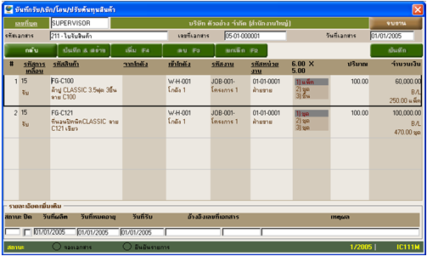

**Figure 2.1 PDP Inventory Control program Review**

## Software Description

This program offers a convenient feature for the user, it used for the controlling inventory of the company including the comprehensive database of stock management and check in/out of the products. It provides a variety of categories and services that aim to help users with the necessary functions for the effective management about inventory.

**Pros**

* Have many functions to calculate inventory.
* Have multiple inventories.
* Support products that have serial number and barcode.
* Can transfer products between inventories.
* Can estimate the ingredient that needs to use per one time.
* Can transfer products between inventories.

## Cons

* Numerous of function may make user confuse to use in some feature.
* No order system support.
* No membership and login support.

## Absolute |Solutions|

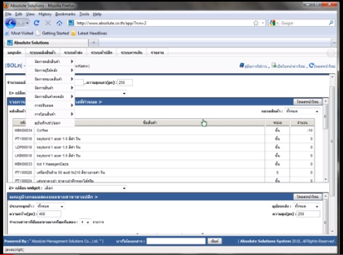

**Figure 2.2 Absolute |Solutions| web Review**

## Software Description

This website is the stock management website that using technology cloud computing that provides server, database, and IT expert. The aims are to improve company to better management. By use the feature of the internet and cloud computing.

## Pros

* Each data is security from virus on machine.
* The user can save investment.
* Support using this web site with every operation system.
* Support alert message with SMS and email.

## Cons

* Support only internet access areas.
* No estimate the inventory.

## CD Organizer

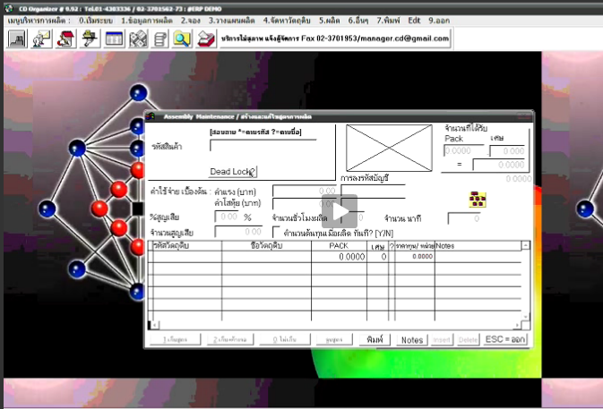

**Figure 2.2 CD Organizer program Review**

## Software Description

This program is the management program in the enterprise. It’s has many feature to support such as purchase system, debtor system, inventory control system and payroll system.

## Pros

* Have hot key using to work faster.
* Online interactive.
* Can show report in the other program such as Microsoft office.
* Coverage report type function.

## Cons

* Support only customer side.
* No membership and login support.
* Numerous of function may make user confuse to use in some feature.

## Technology Review

## Spring Framework



**Figure 2.3 Spring Framework Review**

## Technology Detail

The spring framework is an open source tool for supporting Java-based enterprise application development. This framework use to develop any java application and make J2EE easy to use. It contains pattern and configuration for programming which can be deployed on any platform. It also supports various components to work together such as JDBC and Hibernate.

## Alternative Technology

* ASP.NET Framework

## The selection of this technology

* Support MVC pattern.
* Support .Net and java.
* Easy for unit testing when split it to another part with JUnit.
* Support to connect with various components and technologies.

## Cascading Style Sheets (CSS)



**Figure 2.4 CSS Review**

## Technology Detail

CSS is stands for Cascading Style Sheets. It is a last version of CSS style sheets used to design element of website such as layout, color, size or font of website. Then display HTML elements that presentation of web pages.

## The selection of this technology

- CSS make web pages look better than only HTML does.

- Helps to design the web flexibility.

- Redesign (i.e. colors, size, fonts) with not has effect to HTML code.

- The feature more than the old version such as Combinatory, CSS Selectors, Pseudo-elements, Style properties.

## HTML5



**Figure 2.5 HTML5 Review**

## Technology Detail

HTML5 is the lasts revision of the HTML. It is a markup language to create a user interface for present contents that can be displayed in a web browser.

## Alternative Technology

* Another HTML version
* XHTML

## The selection of this technology

- Makes creating accessible sites easier.

**-** Allow other can access content easily.

**-** Simple and clean.

**-** Easy to handle error.

**-** Reduce the external plug-in such as flash.

**-** Support for local storage.

**-** New content-specific elements, like <article>, <footer> and <header>.

**-** New form controls, like calendar, date, time, email and URL.

## Development Tool Review

## NetBeans



**Figure 2.6 NetBeans Review**

## Development Tool Description

NetBeans is an open-source program to integrated development environment for developing with any language such as Java, PHP, C++ and other programming language. It is referred to developing Java desktop applications and also develops web application. It's constantly improving Java Editor, provide many features and an extensive range of tools, templates and samples.

## Alternative Tool

* Eclipse
* IntelliJ IDEA

## The selection of this tool

* Open source for any users no need license or contract.
* Provide many features necessary for MVC pattern development.
  + Support Ant and Maven – no custom built system that only works in the IDE.
  + Includes new features for editing/debugging HTML5.
  + Written using swing.
  + Built-in support for version control systems plug-ins. For example, it can be a nightmare to get SVN configured correctly on 64 bit systems.

## MySQL Workbench



**Figure 2.7 MySQL Workbench Review**

## Development Tool Description

MySQL Workbench is an open source relational database management system which used for develop database architects. It can do such as provides data modeling, comprehensive administration tools for server configuration, SQL development, user administration and backup. Then also supports many development tool for create a web application such as Eclipse, NetBeans.

## Alternative Tool

* Microsoft Access
* SQLite
* TomCat
* Appserve

## The selection of this tool

* Easy to integrate with many development tool.
* Provide many features support.
* More security.
* Flexible for using and manage via other tool.
* Can visualize table relationships.

## Adobe Dreamweaver



**Figure 2.8 Adobe Dreamweaver Review**

## Development Tool Description

Adobe Dreamweaver is the tool for design and develop the website that provides a visual interface for making and editing HTML websites.

## Alternative Tool

* Notepad++
* CoffeeCup Free HTML Editor
* PageBreeze
* TextMate

## The selection of this tool

## Complete function that necessary to create website.

* Work with offline.
* Support with layout tool.
* Can split the code and design of the webpage at the same time.

# **Chapter Three | Quality Standard**

## 3.1 ISO29110 for Very Small Entity (VSE)

ISO29110 is a guide applies to a Very Small Entity (VSE), enterprise, organisation, department or project up to 25 people, dedicated to software development. The Guide provides Project Management and Software Implementation processes which integrate practices based on the selection of ISO/IEC 12207- *Systems and Software Engineering —Software Life Cycle Processes* and ISO/IEC 15289 *Software Engineering – Software Life Cycle Process – guidelines for the content of software life cycle process information products (documentation)* standards elements.

### Project Management Process

The purpose of the Project Management Process is to improve the success rate of projects in all areas of knowledge, which allows complying with the project’s objectives in the expected quality, time and cost.

**Activities**

* Project Planning Process
* Project Plan Execution Process
* Project Assessment and Control Process
* Project Closer Process

### Software Implementation Process

The purpose of the Software Implementation process is the systematic performance of the analysis, design, construction, integration and tests activities for new or modified software products according to the specified requirements.

**Activities**

* Software Implementation Initiation Process
* Software Requirements Analysis Process
* Software Architectural Design Process
* Software Construction Process
* Software Integration and Test Process
* Software Delivery Process

# **Chapter Four | Project Plan**

## Motivation

Nowadays, many manufacturers have large their database in every department. Some manufacturer can manage their data, and some are cannot. There are many solutions to solve this problem such as an increase workers, spent more budget that unclaimed or expend time to solve it. By the way, as the technology is growing every day, some company turn it as an advantage by use the system to help them solve the problem by managing data in their company.

So we realize that using normal order management system and stock management system to solve the problem for control and manage the data is easy and faster way to solve the problem, but the disadvantages about this way are each data cannot be analyze their summary to apply with other department of the company and cannot be forecast the inventory to limit their manufacturing. We are unable to manage it anymore even if the companies are collect the entire data from the program to analyze and plan to resolve their management by themselves, the resolving still continues because the company not knows about real defect of the department, they just continue to resolving it in every time that found the problems.

With these reasons, we think there must be some system to manage the problems that can help the customer and the company who needs to know their internal data in the company. This system should still able to use forecasting for limiting their cost which can be controlled and has more function to help solve these problems more easily, thereby resulting in “Manufacturing Forecasting”.

## Aims and Objectives

**4.2.1 Aims**

The aim of this project is to develop a website that provides inventory management, forecasting manufacturing and report to company, also to be a commerce website that makes an order with the company as quick and easy as possible.

**4.2.2 Objectives**

* Alternative way to help manufacturing forecasting inventory and summary inventory history.
* Provide a graphic user interface to users that they can understand and easy to use.
* Increasing the effectivenessof the manufacturer will control their standard.
* Increasing a strictness of the manufacturing will limit their budget.
* Provide multiple the systems to help company can handle their work.
* Any workflows of the department are summary into report.

## Deliverables and Limits

### Deliverables

1) 1st progress

- Homepage, registration page and item report page

- Registration and login system

- Report lost item system

- Report found item system

2) 2nd progress

- Social network sharing

- Google map with all location of lost and found items

- Crime reporting

- Reward board

3) 3rd progress

- Notification alert to member’s e-mail

- Charity system

4) The document and other material

- Proposal

- Project plan

- Quality plan

- Software requirement specification

- Traceability record

- Software design document

- Testing document

* Test plan
* Unit test report
* System Test report

- 1 CD-ROM stores all source code; relate file, all documents and poster files in PDF format.

- 1 project poster

### Limits

* The application requires Internet connection to execute.
* Membership is required for using all function in the application.
* The main scope of application is used for reporting only.
* No guarantee that property will be returned to the actual owner.
* The application can work well on PC or laptop only because the system need higher performance and bigger display screen than a mobile device.
* The application use only Chiang Mai map as a sample for developing and testing the system.
* The application allows the user to share each topic via social network but cannot manage the post after sharing to other system such as Facebook system or Twitter system.

## Schedule & Milestones

**Notation:**

Feature #1: Consists of user registration page, homepage and report page.

Feature #2: Consists of registration and login system.

Feature #3: Consists of lost item reporting system.

Feature #4: Consists of found item reporting system.

Feature #5: Consists of social network sharing system.

Feature #6: Consists of location base and map system.

Feature #7: Consists of crime reporting, reward board and other pages.

Feature #8: Consists of Notification alert system.

Feature #9: Consists of charity system.

**Schedule plan:**

Proposal phase: Create proposal document.

Progress I: Create Development plan, Quality plan, SRS, SDD and some part of Test document. Start creates feature# 1, 2, 3, 4 of system.

Progress II: Create feature# 5, 6, and 7 of the system, overall of the system should be higher than 70%. Continue on Test document.

Progress ShowPro: Create feature# 8, 9 of the system and integrate all features. Overall of the system should be complete or nearly. Continue on Test document.

Final progress: Integrate and review all document. Make sure all system and document are complete.

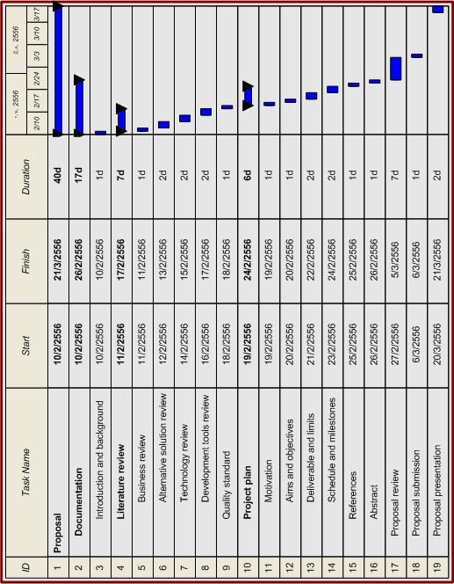

**Figure 4.1: Proposal Milestone**

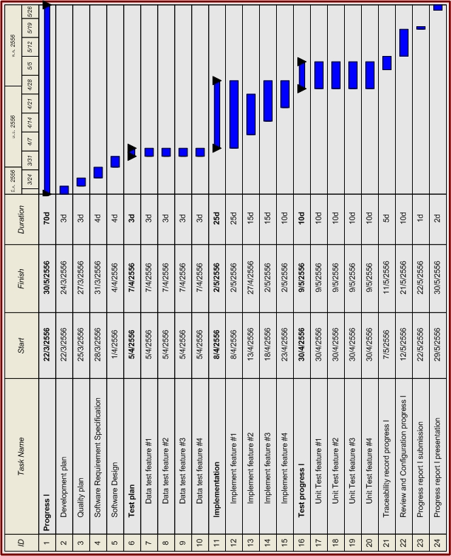

**Figure 4.2: Progress Report I Milestone**

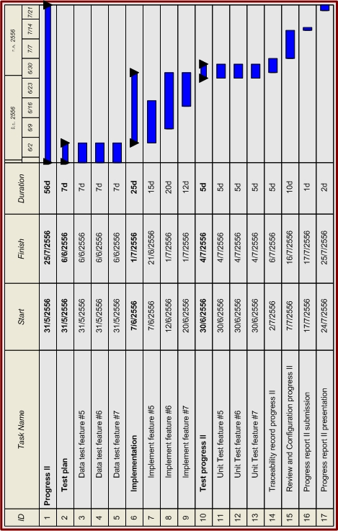

**Figure 4.3: Progress Report II Milestone**

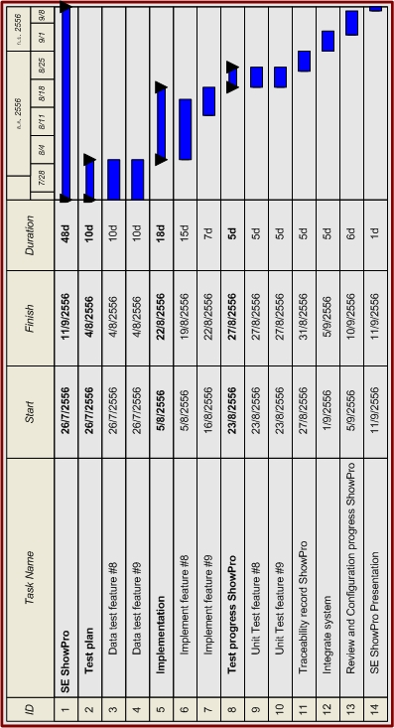

**Figure 4.4: Progress Report ShowPro Milestone**

# **C:\Users\WindnesS\Desktop\Application\Third year\Senior Project\Draft\Final progress.jpg**

**Figure 4.5: Final Progress Report Milestone**

# **Chapter Five | References**

[1] Adobe Dreamweaver CS6. Available from <http://www.adobe.com/products/dreamweaver.html>

[2] CSS. Available from <http://en.wikipedia.org/wiki/Cascading_Style_Sheets>

[3] VSE. Available from http://profs.etsmtl.ca/claporte/English/VSE/Deploy-Pack/Entry

[4] HTML. Available from <http://en.wikipedia.org/wiki/HTML>

[5] HTML5. Available from <http://www.w3schools.com/html/html5_intro.asp>

[6] Lostandfound.com. Available from http://www.lostandfound.com

[7] Lostandfoundpets.ie. Available from http://www.lostandfoundpets.ie

[8] MySQL. Available from http://en.wikipedia.org/wiki/MySQL

[9] Netbeans. Available from http://www.softpicks.com/software/Development/Miscellaneous/

NetBeans-IDE-180921.htm

[10] Spring Framework. Available from http://www.springsource.org/spring-framework

[11] CSS3. Available from [Craig Cook](http://www.amazon.com/s/ref=ntt_athr_dp_sr_1?_encoding=UTF8&field-author=Craig%20Cook&search-alias=digital-text&sort=relevancerank) and [Jason Garber](http://www.amazon.com/s/ref=ntt_athr_dp_sr_2?_encoding=UTF8&field-author=Jason%20Garber&search-alias=digital-text&sort=relevancerank), Foundation HTML5 with CSS3 (New York: friendsofED, 2012), pp. 17-36

[12] MySQL. Available from [Larry Ullman](http://www.amazon.com/s/ref=ntt_athr_dp_sr_1?_encoding=UTF8&field-author=Larry%20Ullman&search-alias=books&sort=relevancerank), MySQL, Second Edition (San Francisco: Peachpit Press, 2006), pp. x-xiii